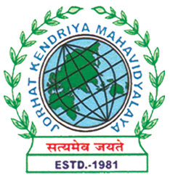
Department of Political Science
JORHAT KENDRIYA MAHAVIDYALAYA
Re-accredited by NAAC with Grade A

KENDUGURI, JORHAT-785 010, ASSAM
Phone # 0376-2350009, 75778 00691(M) e-mail: Politicalsciencejkm@gmail.com
Website : www/jorhatkendriyamahavidyalaya.in

Ref………………… Date: 09-03-2026

Report on the Celebration of International Women’s Day
The Department of Political Science, Jorhat Kendriya Mahavidyalaya, in collaboration with the Gender Neutral Club, organized a special lecture to mark the celebration of International Women’s Day on 8th March. The programme was conducted under the theme “From Awareness to Action: Making Gender Equality a Daily Practice.”
The session was delivered by Dr. Rakhi Dhaka, Assistant Professor of Sociology at Lady Irwin College, University of Delhi. In her lecture, Dr. Dhaka emphasized the need to move beyond mere awareness of gender issues and focus on actively incorporating gender equality into everyday practices. She highlighted how individual actions, attitudes, and social interactions play a crucial role in shaping a more inclusive and equitable society.
The lecture was both insightful and engaging, providing participants with a deeper understanding of gender dynamics and encouraging them to critically reflect on their own roles in promoting equality. The interactive nature of the session allowed students to engage in meaningful discussions and gain practical perspectives on implementing gender-sensitive approaches in their daily lives.
The programme was well-attended by students and faculty members, and it successfully contributed to raising awareness while also motivating participants to translate knowledge into action. The event concluded with a vote of thanks, acknowledging the valuable contribution of the speaker and the collaborative efforts of the organizing bodies.

Signature
Udipta Borah
HoD, Dept. of political Science, Jorhat Kendriya Mahavidyalaya

