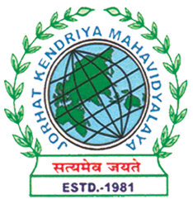
Department of Political Science
JORHAT KENDRIYA MAHAVIDYALAYA
Re-accredited by NAAC with Grade A

KENDUGURI, JORHAT-785 010, ASSAM
Phone # 0376-2350009, 75778 00691(M) e-mail: Politicalsciencejkm@gmail.com
Website : www/jorhatkendriyamahavidyalaya.in

Ref………………… Date: 09-03-2026

Report on the Celebration of International Women’s Day
The Department of Political Science, Jorhat Kendriya Mahavidyalaya, in collaboration with the Gender Neutral Club, organized a series of programmes to mark the celebration of International Women’s Day on 7th and 8th March 2026.
As part of the celebration, the Department organized a speech competition on 7th and 8th March, centered on themes related to women’s issues. The competition provided students with a valuable platform to articulate their thoughts and perspectives on gender equality, women’s rights, and empowerment. Participants showcased critical thinking, awareness, and a strong commitment to social issues through their speeches.
In addition to this, students presented a short drama that powerfully depicted the everyday realities of patriarchy and violence in society. The performance was impactful and thought-provoking, effectively highlighting the challenges faced by women and the urgent need for societal change.

Signature
Udipta Borah
HoD, Dept. of political Science, Jorhat Kendriya Mahavidyalaya

