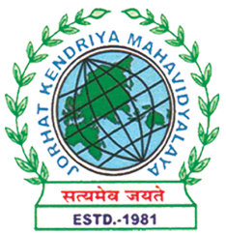
Department of Political Science
JORHAT KENDRIYA MAHAVIDYALAYA
Re-accredited by NAAC with Grade A

KENDUGURI, JORHAT-785 010, ASSAM
Phone # 0376-2350009, 75778 00691(M) e-mail: Politicalsciencejkm@gmail.com
Website : www/jorhatkendriyamahavidyalaya.in

Ref………………… Date: 09-03-2026
The Department of Political Science, Jorhat Kendriya Mahavidyalaya, organized a Parent-Teacher Meeting on 7th March 2026 with the objective of strengthening communication and collaboration between parents and faculty members.
The meeting served as a platform to discuss students’ academic performance, attendance, participation in departmental activities, and overall development. Faculty members interacted with parents and provided feedback on students’ progress, while also addressing concerns and suggestions raised by the parents.
The interaction was constructive and meaningful, helping to build a better understanding of students’ needs and the role of both teachers and parents in supporting their academic and personal growth. The meeting also emphasized the importance of regular engagement and cooperation to ensure a conducive learning environment.
The programme was well-attended and concluded successfully, reinforcing the importance of parent-teacher collaboration in enhancing the overall educational experience of students.

Signature
Udipta Borah
HoD, Dept. of political Science, Jorhat Kendriya Mahavidyalaya

