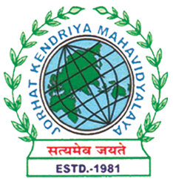
Department of Political Science
JORHAT KENDRIYA MAHAVIDYALAYA
Re-accredited by NAAC with Grade A

KENDUGURI, JORHAT-785 010, ASSAM
Phone # 0376-2350009, 75778 00691(M) e-mail: Politicalsciencejkm@gmail.com
Website : www/jorhatkendriyamahavidyalaya.in

Ref………………… Date: 10-04-2026
Resolution
It is hereby resolved that for the First Sessional Examination of B.A.2nd , 4th , and 6th Semester students of the Department of Political Science, special measures were undertaken to support students who did not attain the basic pass marks. An additional examination was conducted on 6th April. 2026,to provide such students with an opportunity to improve and secure the minimum qualifying marks.
Further, for absentee students and those who were unable to pass in the first sessional examination, another examination was organized on 6th April 2026. Based on the performance in these examinations, the marks were duly evaluated and mark sheets were prepared accordingly.
This resolution is adopted to ensure fairness, inclusivity, and academic support for all students.

Signature
Udipta Borah
HoD, Dpt of political Science, Jorhat Kendriya Mahavidyalaya

