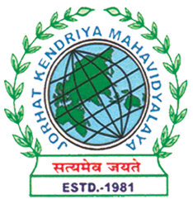
Department of Political Science
JORHAT KENDRIYA MAHAVIDYALAYA
Re-accredited by NAAC with Grade B++

KENDUGURI, JORHAT-785 010, ASSAM
Phone # 0376-2350009, 75778 00691(M) e-mail: Politicalsciencejkm@gmail.com
Website : www/jorhatkendriyamahavidyalaya.in

Ref…………………. Date: 05/10/2023

Learning through Movies: Screening of "Rocketry: The Nambi Effect"
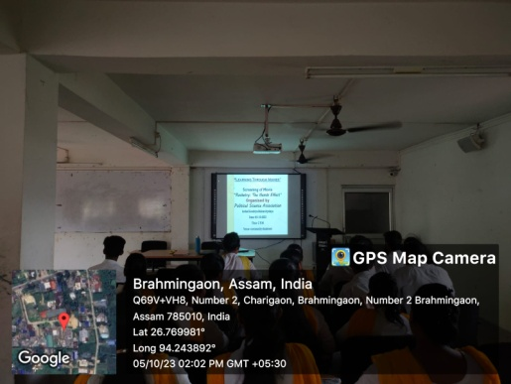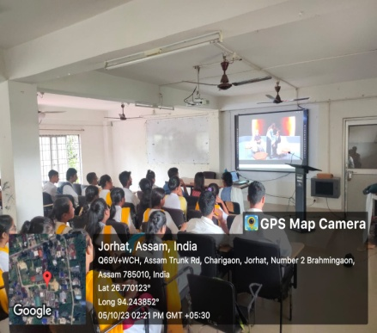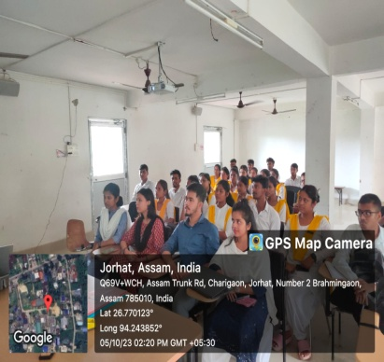
The Department of Political Science at Jorhat Kendriya Mahavidyalaya organized a "Learning Through Movies" session on October 5, 2023, where the film "Rocketry: The Nambi Effect" was screened at the Community Classroom from 2 p.m. onwards. The event was attended by major students from the department, along with the faculty members.
The screening of "Rocketry: The Nambi Effect" was part of the department's initiative to incorporate experiential learning through movies as a pedagogical tool. The film, based on the life of Nambi Narayanan, a former ISRO scientist and aerospace engineer who was falsely accused of espionage, provided students with an opportunity to learn about the challenges faced by individuals in the pursuit of scientific advancement and the importance of political participation in ensuring justice.
After the screening, a movie review session was held, where students and faculty members discussed the film's portrayal of the political and social issues surrounding Nambi Narayanan's case. The discussion highlighted the role of the media in shaping public opinion, the need for transparency in government institutions, and the importance of protecting the rights of individuals.

Udipta Borah
HOD,
Dept. of Political Science

