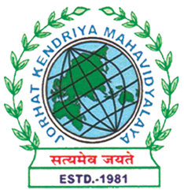
Department of Political Science
JORHAT KENDRIYA MAHAVIDYALAYA
Re-accredited by NAAC with Grade A

KENDUGURI, JORHAT-785 010, ASSAM
Phone # 0376-2350009, 75778 00691(M) e-mail: Politicalsciencejkm@gmail.com
Website : www/jorhatkendriyamahavidyalaya.in

Ref………………… Date: 09-11-2023
Report on Intra Institutional Idea Competition at Jorhat Kendriya Mahavidyalaya

On November 8, 2023, the Department of Political Science, in collaboration with IIC, Jorhat Kendriya Mahavidyalaya successfully organized an Intra Institutional Idea Competition. The event attended by a diverse audience of 70 students from various departments of the college, along with faculty members. Approximately 20 groups participated in this intellectually stimulating competition, showcasing their innovative ideas and problem-solving skills.
The first prize was awarded to Kongkona Pathak, a 5th-semester student from the Department of Political Science, and her team. Their winning topic, "Electric Vehicle: A Smart Choice for Environment in India," highlighted the potential of electric vehicles in reducing environmental impact in India.
Barbie Bora and her team, students from the Department of Political Science, 5th semester, secured the second prize with their innovative idea, "Innovative Idea for Conducting Fair and Transparent Elections in India." This topic aimed to improve the electoral process in India by introducing new methods for ensuring fairness and transparency.
Tushar Sahu and his team, also students from the Department of Political Science, won the third prize with their topic "Effective Strategies for Voter Engagement in Local Elections." This presentation focused on enhancing voter participation in local elections through strategic engagement methods.
The competition was judged by Arup Kr. Mahanta, Head of Department and Associate Professor in the Department of Economics. His expertise and experience in evaluating innovative ideas ensured fair judgment and insightful feedback for the participants.

This competition not only demonstrated the creativity and innovative spirit of the students but also provided a platform for them to engage in critical thinking and problem-solving. The diverse range of topics presented reflects the intellectual depth and academic excellence fostered at Jorhat Kendriya Mahavidyalaya.
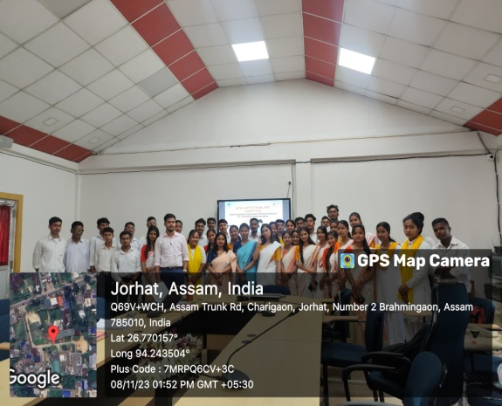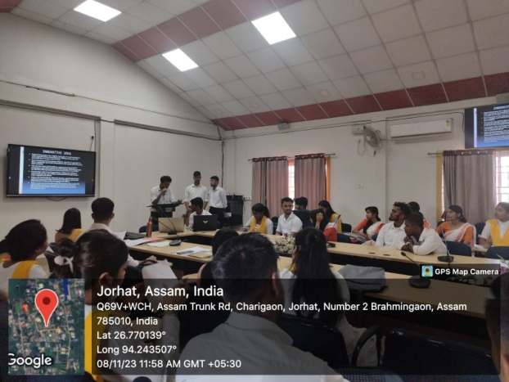

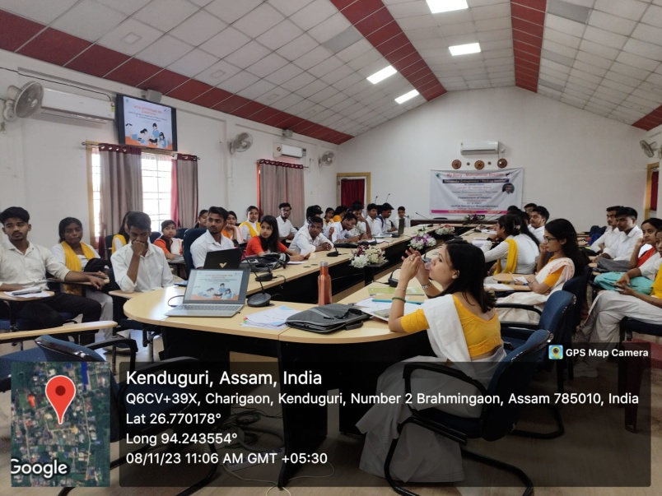
Udipta Borah
HOD, Dept. of Political Science
Jorhat Kendriya mahavidyalaya

