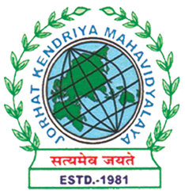
Department of Political Science
JORHAT KENDRIYA MAHAVIDYALAYA
Re-accredited by NAAC with Grade A

KENDUGURI, JORHAT-785 010, ASSAM
Phone # 0376-2350009, 75778 00691(M) e-mail: Politicalsciencejkm@gmail.com
Website : www/jorhatkendriyamahavidyalaya.in

Ref………………… Date: 11/12/2023
Report on Celebration of International Day of Elimination of Violence against Women

On the occasion of the International Day of Violence Against Women on November 25, 2023, the Department of Political Science, in collaboration with the Internal Quality Assurance Cell (IQAC) at Sarojini Devi Ucchatar Madhyamik Vidyalaya, organized an outreach activity aimed at raising awareness and empowering young minds. The event featured a poster-making competition involving students from Sarojini Devi Ucchatar Madhyamik Vidyalaya.

Event Highlights:
The program was skillfully hosted by Bonnya Phukan, Assistant Professor in the Department of Political Science, who ensured the smooth flow of the activities. Miss Puja Das, Assistant Professor from the Department of Political Science, delivered an enlightening talk focusing on the constitutional provisions regarding women's rights, shedding light on legal frameworks that safeguard women's rights.
Miss Udipta Borah, Head of Department of Political Science, addressed the audience on the critical issue of sexual harassment of women and emphasized strategies to protect and empower young girls against such incidents.

Prize Distribution Ceremony
The event culminated in a prize distribution ceremony where the Headmaster of Sarojini Devi Ucchatar Madhyamik Vidyalaya announced the winners of the poster-making competition. Prizes were distributed to the deserving students, recognizing their creativity and commitment to advocating for women's rights and safety.

This outreach activity not only provided a platform for students to express their views creatively but also served as a significant step towards fostering a culture of gender equality and empowerment within the educational community. The engagement of students in such initiatives is crucial in promoting awareness and instilling values of respect and equality from a young age.
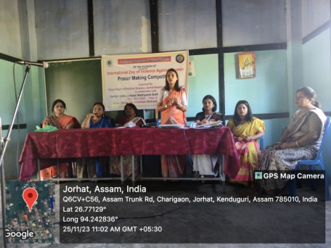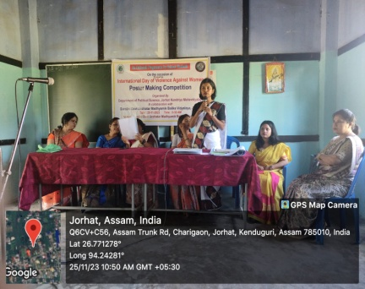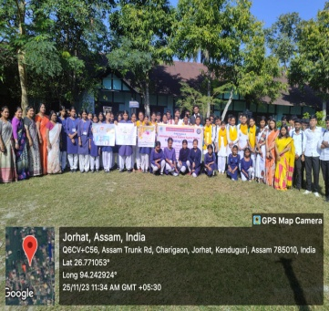
Udipta Borah
HOD, Dept. of Political Science,
JKM

