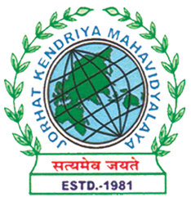
Department of Political Science
JORHAT KENDRIYA MAHAVIDYALAYA
Re-accredited by NAAC with Grade A

KENDUGURI, JORHAT-785 010, ASSAM
Phone # 0376-2350009, 75778 00691(M) e-mail: Politicalsciencejkm@gmail.com
Website : www/jorhatkendriyamahavidyalaya.in

Ref………………… Date: 11/12/2023
Report on International Human Rights Day 2023

On December 10, 2023, the Department of Political Science, in collaboration with the IQAC, Jorhat Kendriya Mahavidyalaya organized an online event to commemorate International Human Rights Day. The keynote speaker for the occasion was Mr. Jyotishman Bora, Faculty at Gauhati Law College, who delivered an insightful presentation on the genesis of human rights in Assam and the three generations of rights and their violations.
The program was hosted by Mr. Debashish Borah, Assistant Professor in the Department of Political Science. The event was attended by faculty members from various departments of JKM as well as students.
Mr. Bora's address provided a comprehensive overview of the historical development of human rights in the Assam region. He discussed the three generations of rights - civil and political rights, economic, social and cultural rights, and collective rights - and highlighted the challenges and violations faced in each category.
The presentation was followed by an engaging question-and-answer session, where attendees had the opportunity to interact with the speaker and gain deeper insights into the human rights landscape in Assam.
The event concluded with a vote of thanks delivered by Ms. Udipta Borah, Head of the Department of Political Science, who expressed gratitude to the speaker, the organizers, and all the participants for their valuable contributions.
Overall, the International Human Rights Day celebration at JKM University provided a platform to raise awareness about human rights issues, foster dialogue, and inspire the academic community to continue advocating for the protection and promotion of fundamental freedoms and dignity for all.
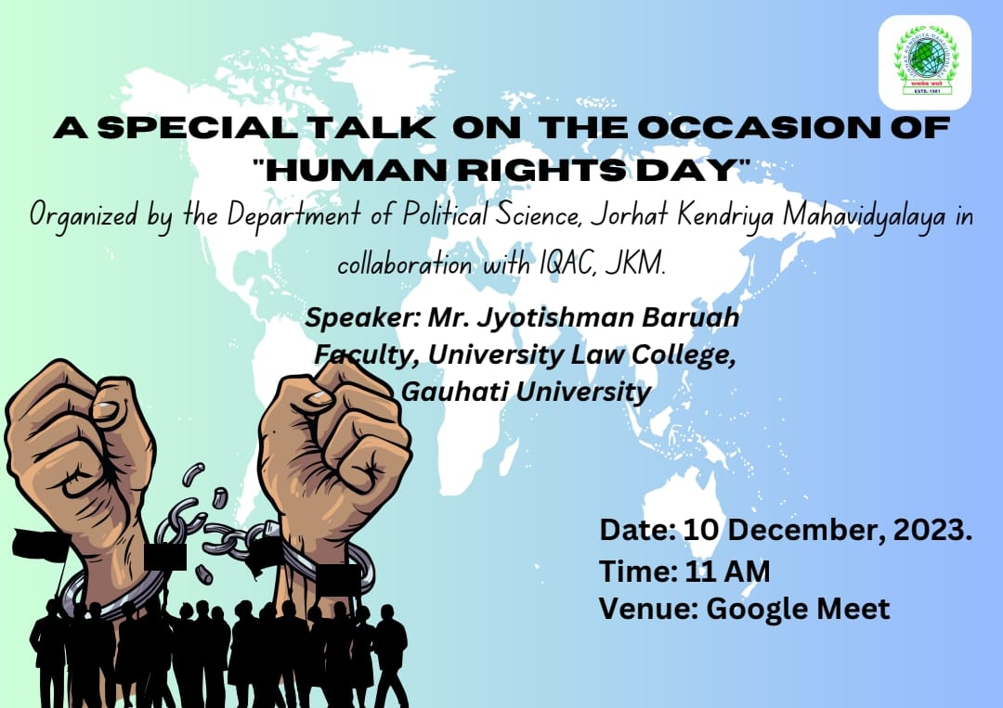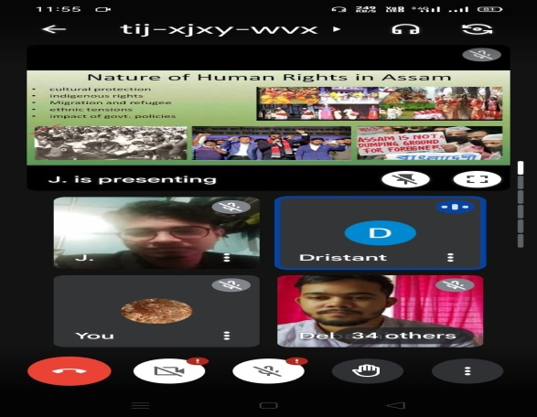

Udipta Borah
HOD, Dept. of Political Science,
JKM

