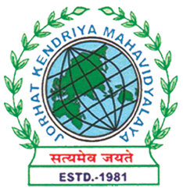
Department of Political Science
JORHAT KENDRIYA MAHAVIDYALAYA
Re-accredited by NAAC with Grade A

KENDUGURI, JORHAT-785 010, ASSAM
Phone # 0376-2350009, 75778 00691(M) e-mail: Politicalsciencejkm@gmail.com
Website : www/jorhatkendriyamahavidyalaya.in

Ref………………… Date: 13-01-2024
Report on National Youth Day Event Organized by Department of Political Science, JKM

The Department of Political Science at Jorhat Kendriya Mahavidyalaya (JKM), in collaboration with IQAC, JKM, organized an event to celebrate National Youth Day on January 12, 2024.
The highlight of the event was a special talk delivered by Miss Jayashree Sarma, Assistant Professor in the Department of Political Science at Kokrajhar Government College, BTC. Miss Sarma joined the event through an online mode and addressed the audience on the topic of "Swami Vivekananda's Contribution to the Youth Mind and Developing a Positive Mindset".
During her insightful presentation, Miss Sarma delved into the life and teachings of Swami Vivekananda, emphasizing his profound impact on the youth of India. She discussed how Vivekananda's philosophy of self-reliance, spiritual awakening, and social service can inspire and empower the younger generation to develop a positive mindset and work towards the betterment of society.
The event was hosted by Miss Udipta Borah, the Head of the Department of Political Science, who welcomed the guest speaker and the attendees. The session was attended by faculty members from the Department of Political Science, as well as students, who actively engaged in the discussion and asked thought-provoking questions.

The event provided a platform for the participants to gain a deeper understanding of Swami Vivekananda's legacy and its relevance in shaping the minds of the youth. It also highlighted the importance of fostering a positive and empowered mindset among the younger generation, which is crucial for their personal and professional development, as well as for the overall progress of the nation.
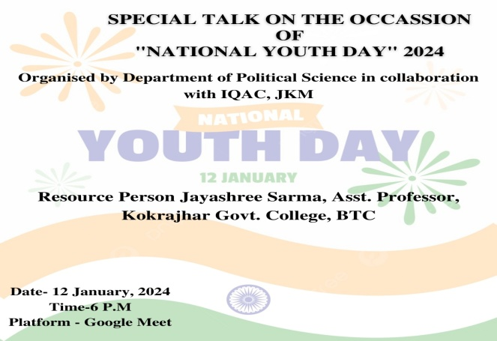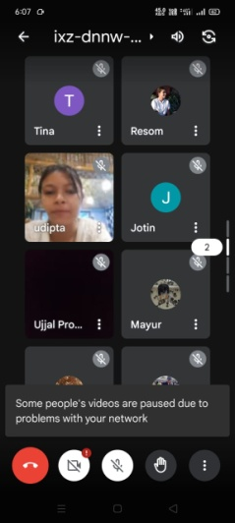

Udipta Borah
HOD, Dept. of Political Science
JKM

