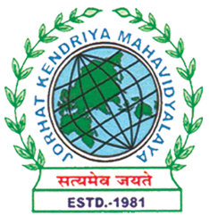
Department of Political Science
JORHAT KENDRIYA MAHAVIDYALAYA
Re-accredited by NAAC with Grade A

KENDUGURI, JORHAT-785 010, ASSAM
Phone # 0376-2350009, 75778 00691(M) e-mail: Politicalsciencejkm@gmail.com
Website : www/jorhatkendriyamahavidyalaya.in

Ref………………… Date: 20-01-2024

Report on National Youth Day 2024

The Department of Political Science, in collaboration IIC, Jorhat Kendriya Mahavidyalaya, JKM organized a significant event on January 19, 2024, to commemorate National Youth Day. The occasion featured an Intra-Institutional Essay Writing Competition centered on the theme of "Digital Revolution: Youth's Role in Shaping the Future."
Mrs. Nibedita Baruah, the Head of the Department of History at JKM, served as the esteemed judge for the competition. Her expertise and insights added value to the event, guiding participants on the importance of the youth in shaping the future. She also delivered an insightful talk during the event, shedding light on the crucial role that the youth play in shaping the future. Her words inspired and motivated the participants, emphasizing the power and responsibility that the youth hold in influencing the digital revolution.
The event was hosted by Udipta Borah, the Head of the Department of Political Science at JKM. The event witnessed a significant turnout, with faculty members from the Department of Political Science and other departments, as well as enthusiastic students, actively engaging in the session. The diverse audience contributed to a vibrant and enriching discussion on the youth's role in shaping the future through the digital revolution. Lastly, vote of thanks was delivered by Mr. Debashish Borah, Asst. professor from dept of Political science. The event was a resounding success, fostering intellectual discourse, and highlighting the critical role of the youth in driving forward the digital transformation of society.
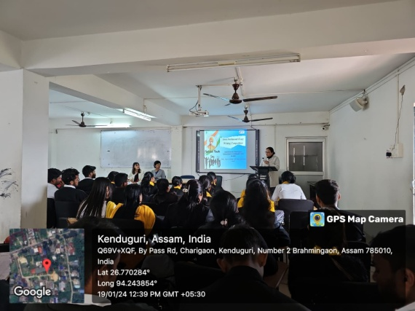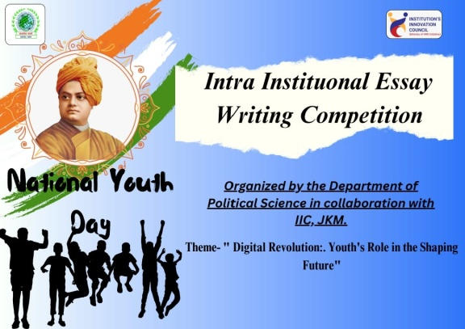

Udipta Borah
HOD, Dept of Political Science
JKM

