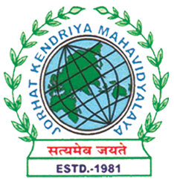
Department of Political Science
JORHAT KENDRIYA MAHAVIDYALAYA
Re-accredited by NAAC with Grade A

KENDUGURI, JORHAT-785 010, ASSAM
Phone # 0376-2350009, 75778 00691(M) e-mail: Politicalsciencejkm@gmail.com
Website : www/jorhatkendriyamahavidyalaya.in

Ref………………… Date: 25-01-2024

National Girl Child Day was celebrated on January 24, 2024, to raise awareness about the challenges faced by girls in Indian society. The event was organized by the Department of Political Science in collaboration with the Internal Complaint Committee, JKM, and featured Miss Tennisa Bairagey, a Ph.D. Research scholar from NEHU, as the resource person. The session was conducted online and hosted by Miss Bonnya Phukan, Assistant Professor in the Department of Political Science. The program focused on girls' safety in the digital era and on social media platforms. Faculty members and students from the college participated in the event, emphasizing the importance of empowering and protecting girls in today's digital world.
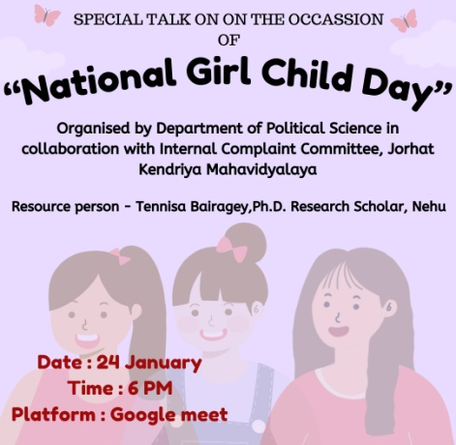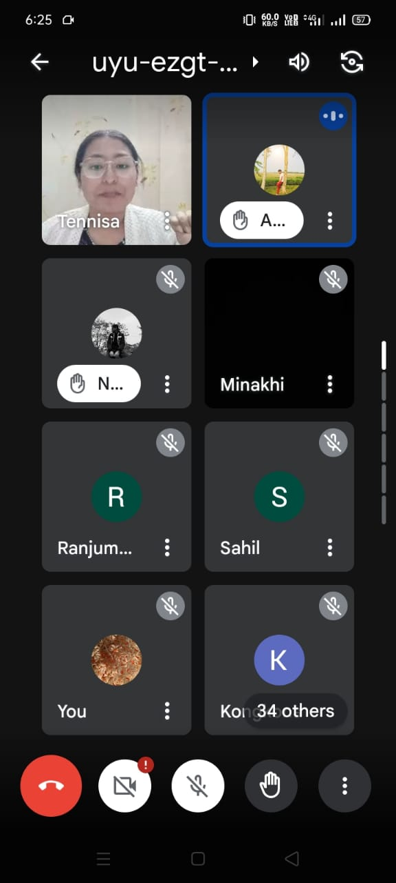
Udipta Borah
HOD,Dept. of Political Science,JKM

