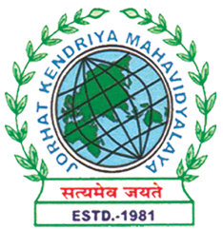
Department of Political Science
JORHAT KENDRIYA MAHAVIDYALAYA
Re-accredited by NAAC with Grade A

KENDUGURI, JORHAT-785 010, ASSAM
Phone # 0376-2350009, 75778 00691(M) e-mail: Politicalsciencejkm@gmail.com
Website : www/jorhatkendriyamahavidyalaya.in

Ref………………… Date: 26/01/2024

Report on Outreach Activity on National Voters Day

The Department of Political Science, Jorhat Kendriya Mahavidyalaya, in collaboration with the Election Office, Jorhat, organized an outreach activity on the occasion of National Voters Day on January 25, 2024. The event aimed to raise awareness about the importance of voting and promote women's political participation in the electoral process. The activity involved a field visit to Osoibari Village, Hatigarh area in Jorhat District, where students from the Department of Political Science and officials from the Election Commission, Jorhat, conducted a survey on the topic "Attitude towards Women's Political Participation.
On the day of the event, a team of students from the Department of Political Science, accompanied by officials from the Election Office, Jorhat, visited Osoibari Village. The team conducted a survey among almost 100 women and men from the village to gauge their attitudes towards women's political participation. The survey aimed to understand the perceptions and opinions of the villagers regarding the role of women in politics and their willingness to participate in the electoral process.
The survey revealed that a significant number of respondents (60%) believed that women should participate more actively in politics. However, a substantial proportion (40%) felt that women were not suitable for political roles due to various reasons such as lack of education, family responsibilities, and societal expectations. The survey also highlighted that many respondents (70%) were unaware of the importance of voting and the role it plays in shaping the country's future.
To raise awareness about the voting process and the importance of casting votes, officials from the Election Office, Jorhat, demonstrated an Electronic Voting Machine (EVM) to the villagers. The demonstration aimed to educate the villagers on how to use the EVM and the significance of voting in the democratic process. The event was well-received by the villagers, who appreciated the efforts of the organizers to educate them on the electoral process.
The outreach activity on National Voters Day was a significant success in promoting awareness about the importance of voting and women's political participation. The survey conducted by the students from the Department of Political Science highlighted the need for greater awareness and education among the villagers regarding the electoral process and the role of women in politics. The demonstration of the EVM by officials from the Election Office, Jorhat, further emphasized the importance of voting in shaping the country's future. The event was a valuable learning experience for the students, who gained hands-on experience in conducting a survey and interacting with the local community.
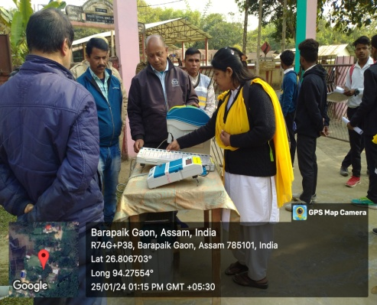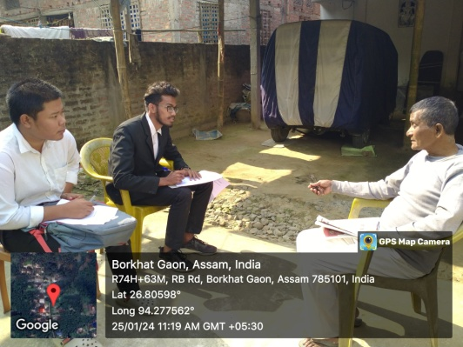
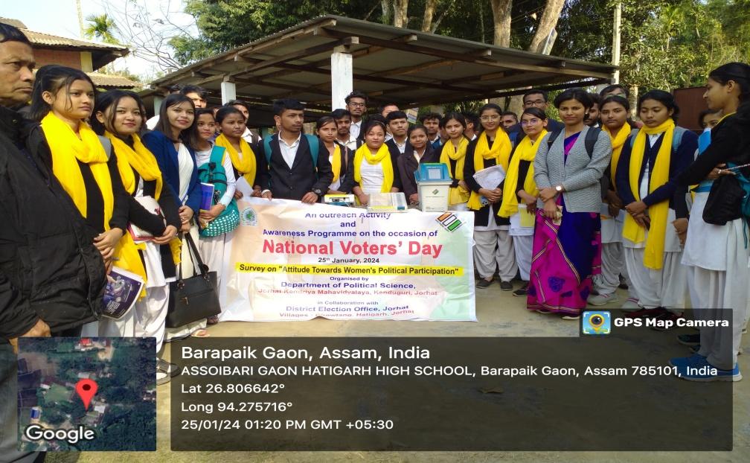

Udipta Borah
HOD, Dept. of political science

