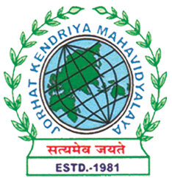
Department of Political Science
JORHAT KENDRIYA MAHAVIDYALAYA
Re-accredited by NAAC with Grade A

KENDUGURI, JORHAT-785 010, ASSAM
Phone # 0376-2350009, 75778 00691(M) e-mail: Politicalsciencejkm@gmail.com
Website : www/jorhatkendriyamahavidyalaya.in

Ref………………… Date: 22-04-2024

Report on World Creativity and Innovation Day Event

The Department of Political Science, in collaboration with the Innovation and Incubation Center (IIC) and Jorhat Kendriya Mahavidyalaya (JKM), organized an event to celebrate World Creativity and Innovation Day on April 21, 2024. The theme of the event was "Ethnic Fashion Design and Sustainability."
The keynote speaker for the event was Dr. Pomima Duarah, Assistant Professor in the Department of Fashion Technology at Assam Women's University. Dr. Duarah provided an insightful presentation on the rich ethnic fashion traditions of Assam and how they can be leveraged to drive economic development and sustainability.
During her address, Dr. Duarah highlighted the unique and vibrant textile heritage of Assam, which includes traditional weaving techniques, intricate embroidery, and the use of natural dyes. She emphasized the importance of preserving and promoting these ethnic fashion practices, as they not only represent the cultural identity of the Assamese people but also have the potential to create sustainable livelihoods for local artisans and weavers.
Dr. Duarah discussed how the integration of ethnic fashion design with modern sustainable practices can lead to the development of a thriving creative economy in Assam. She shared examples of successful initiatives that have combined traditional craftsmanship with eco-friendly materials and production methods, resulting in the creation of high-quality, ethically-sourced fashion products.
The event was hosted by Mr. Debashish Borah, an Assistant Professor from the Department of Political Science. The program was attended by faculty members from Jorhat Kendriya Mahavidyalaya, who engaged in a lively discussion with Dr. Duarah, exploring the potential for collaboration and the implementation of sustainable ethnic fashion initiatives in the region.[1][2]

The vote of thanks was delivered by Miss Udipta Borah, the Head of the Department of Political Science, who expressed gratitude to the organizers, the keynote speaker, and all the attendees for their participation and contribution to the successful celebration of World Creativity and Innovation Day.
Overall, the event provided a platform to showcase the creative potential of Assam's ethnic fashion heritage and its role in driving sustainable development. The collaboration between the Department of Political Science, IIC, and JKM demonstrated the interdisciplinary approach necessary to address the challenges and opportunities in the creative economy.

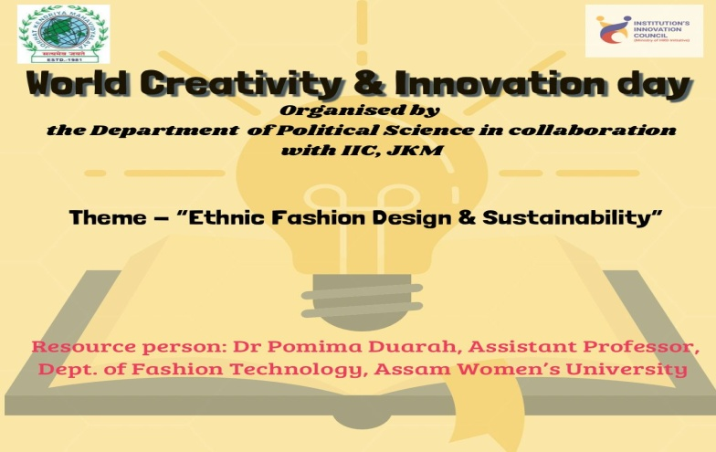

Udipta Borah
HOD, Dept. of Political Science
JKM

