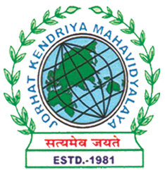
Department of Political Science
JORHAT KENDRIYA MAHAVIDYALAYA
Re-accredited by NAAC with Grade A

KENDUGURI, JORHAT-785 010, ASSAM
Phone # 0376-2350009, 75778 00691(M) e-mail: Politicalsciencejkm@gmail.com
Website : www/jorhatkendriyamahavidyalaya.in

Ref………………… Date: 07-04-2024

Report on Departmental seminar

The Department of Political Science at Jorhat Kendriya Mahavidyalaya organized a departmental seminar on "Political Participation of Women in Indian Politics with Special Reference to Assam" on April 6, 2024. The seminar was attended by students from 2nd, 4th, and 6th semesters, who presented papers on various aspects of women's political participation in India and Assam. The department faculty members hosted the event.
The seminar highlighted the importance of women's political participation in achieving genuine democratic governance and gender equality in India. Participants discussed the challenges and opportunities for Indian women in their quest for political space and an active role in shaping their destiny. They emphasized the need for reservations and quotas at the constitutional or political party level to address the gender imbalance in India's governance system, as demonstrated by the success of political reservations for women at the Panchayati Raj level.
The seminar also discussed the current status of women's representation in decision-making in India and Assam. Participants highlighted the fact that women are extremely underrepresented within all major political parties and are less likely to be nominated as candidates. They also discussed the need to address the democratic deficit that has strong implications for women, whose rights to political participation are violated by their marginalisation from democratic governance.
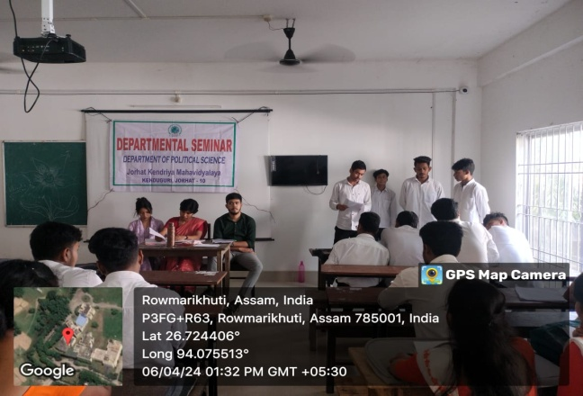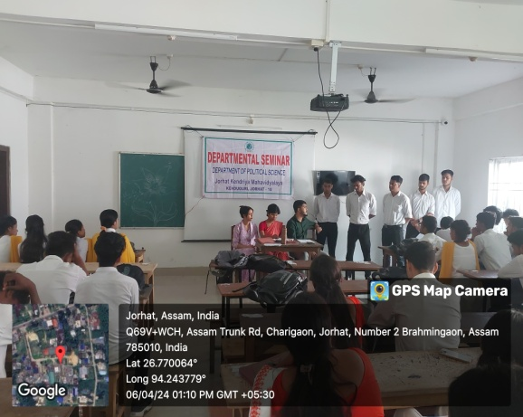
Udipta Borah
HOD,Dept of political science

