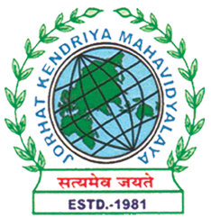
Department of Political Science
JORHAT KENDRIYA MAHAVIDYALAYA
Re-accredited by NAAC with Grade A

KENDUGURI, JORHAT-785 010, ASSAM
Phone # 0376-2350009, 75778 00691(M) e-mail: Politicalsciencejkm@gmail.com
Website : www/jorhatkendriyamahavidyalaya.in

Ref………………… Date: 21-04-2024
Notice
On the occasion of World Creativity and Innovation Day, the Department of Political Science in collaboration with IIC, Jorhat Kendriya Mahavidyalaya is going to organize a significant event on April 22, 2024. We are delighted to announce that Dr. Pomima Duarah, Assistant professor, Department of Fashion Technology, Assam Women’s University, Jorhat as our distinguished resource person, who will be delivering a lecture of great importance and relevance. The theme of the event is “Ethnic fashion design & sustainability”.
The lecture will take place online and we are encouraging all the Major students of the department of Political Science to attend this insightful session. Your presence at this event is not only encouraged but mandatory.
Please mark your calendars and ensure your timely presence.

Event Details:
Date: 22-04-2024
Time: 6 PM onwards
Mode: Online ( Google Meet )

Sincerely
Miss Udipta Borah
HOD
Department of Political Science

